Nathan Busse

Autodesk | Fusion

Table of Contents

**Course prerequisite:** 2

**Introduction to Fusion** 3

**Who is Autodesk?** 4

**What is Autodesk Fusion?** 5

**Why is Autodesk Fusion used by tech-companies in a professional setting?** 6

**Learning the core components of Fusion** 7

New to Fusion 8

Your Autodesk account and Fusion: 10

**Self-paced learning for Fusion** 13

**Introduction to Fusion** 18

# **Course prerequisite:**

1. **Create fully defined sketches.**
2. **Use**:

* Solid
* Freeform
* Direct,
* modelling tools.

1. **Create**

* Construction planes
* Construction axes

1. **Inspect geometry with:**

* Section analysis
* Measure

1. **Create and Manage:**

* Assembly components

1. **Understand:**

* Assembly joints
* Rigid groups
* Motion links
* Interference

1. **Create drawings with:**

* Views
* Annotations
* Title blocks

# **Introduction to Fusion**

 “It is necessary sometimes to take one step backward to take two steps forward” Vladimir Lenin.

# **Who is Autodesk?**

Autodesk, Inc. is a software company that creates 3D design, engineering, and entertainment software. Their products are used by professionals and consumers in many industries.

#### **What they do:**

* Create software for design, engineering, and entertainment.
* Help users visualize and simulate their ideas before being manufactured.
* Provide software for architects, engineers, designers, manufacturers, and more.

#### **What their products include:**

* AutoCAD, a computer-aided design (CAD) software
* Revit, a 3D design software
* Fusion360, a tool for 3D design
* Maya, a software for entertainment
* 3DS Max, a software for 3D design

#### **Where they operate:**

* Headquartered in San Francisco, California
* Have offices worldwide, including in the US, Canada, and other countries.
* Sell their products through resellers, distributors, and their online store.

#### **Who they serve:**

* Architecture, engineering, and construction industries
* Product design and manufacturing industries
* Digital media and entertainment industries

# **What is Autodesk Fusion?**

Autodesk Fusion is a cloud-based software platform that allows users to design and manufacture products. It combines CAD, CAM, CAE, and PCB tools into one platform.

#### **What Autodesk’s Fusion is used for:**

* **Product design**: Create 3D models of products, including sketches, surfaces, and meshes.
* **Manufacturing**: Use machining tools to create parts, including turning, probing, and inspection
* **Simulation**: Run simulations to assess designs
* **Electronics design**: Use schematic design and PCB layout tools to design electronics.

#### **Who uses Autodesk’s Fusion?**

* **Industry professionals**: Engineers, machinists, and industrial designers use Fusion to design and manufacture products.
* **Educators and students**: Eligible students and educators can use a free version of Fusion.

# **Why is Autodesk Fusion used by tech-companies in a professional setting?**

As mentioned earlier, Autodesk Fusion is a cloud-based software package that helps tech companies design and manufacture products more efficiently. Industrial designers and engineers use it to create 3D models, simulate performance, and collaborate in real time.

Benefits of Autodesk Fusion include:

* **Rapid prototyping**: Quickly assess ideas and identify issues early in the design process.
* **Simulation**: Test how a design will work in real-world conditions
* **Collaboration**: Work with others in real time and on the same file
* **Design for manufacturing**: Reduce waste, rework, and production costs.
* **Connected data**: Seamlessly integrate data across design, engineering, and manufacturing.
* **AI and data analytics**: Predict maintenance needs and improve process efficiency.
* **Extensions**: Unlock advanced design and manufacturing technologies

Autodesk Fusion is a cost-effective, scalable, and flexible solution that can be utilized for a variety of purposes, including product design, rapid prototyping, and engineering.

## **Learning the core components of Fusion**

“In my book experience out-ranks everything.” Captain Rex.

## New to Fusion

Autodesk Fusion formerly known as Fusion360 is a cluster of:

* Computer Aided Design (C.A.D)
* Computer Aided Milling (C.A.M)
* Computer Aided Evaluation (C.A.E)
* Printed Circuit Board (P.C.B),

into a single integrated cloud service, Platform as a Service (P.a.a.S).

Fusion is a combination of snappy user-friendly and precise:

* Organic modelling
* Solid modelling,

allowing seamless transition from design to manufacturing products.

With an Autodesk account, Fusion software and the Fusion web-client allows teams to collaborate and share among their members by utilizing projects and secured folders. These projects and secured folders are all stored in the cloud, in a Fusion hub.

The Fusion hub is accessible to you and your fellow team members.

**Diagram representing the flow cycle of Fusion hub:**

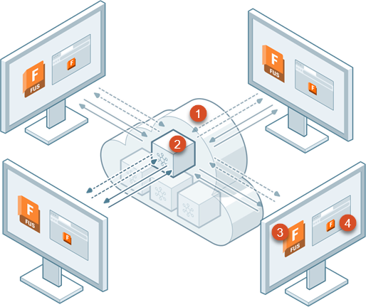

1. Cloud
2. One of several hubs in the cloud.
3. Fusion connected to the hub from a desktop computer (Fusion app).
4. The Fusion web-client (browser), connected to the hub from a desktop computer through the installed fusion app.

## Your Autodesk account and Fusion:

To start using Fusion an administrator needs to invite you to a hub. A hub is a collaborative space where you and your team members work together on designs.

You will receive this invitation via email.

**How to join a hub through a received invitation?**

1. **Click the link on the invitation email.**

**If you know you were invited to join a hub but do not see an invitation in your inbox, do the following:**

* 1. Check your spam email folder.
  2. Make sure your administrator used the correct email address.
  3. If those steps are unsuccessful, open the Fusion web-client and follow the instructions in Switch between hubs to open any hubs you have received an invited to join.

1. **After clicking the email link, a page opens in your browser and one of the two things will happen.**
   * + - If you are new to Autodesk, you will be requested to create an Autodesk account and sign-in.
       - If you already have an Autodesk account, you will then be requested to sign-in, if you have already done so.

Once signed-in, the hub you had been invited to opens in your default browser:

This browser interface is known as the Fusion web-client, which you can use to manage data and projects.

**Tip:** Download Fusion software from the link in the notification banner.

You will also receive a confirmation email to notify you that you have successfully joined the hub.

**Note:** There might be a short transition time where Fusion will indicate that you are currently in a trial period. This will stop when your administrator assigns you a license, at which point you will receive another confirmation email notifying you of the matter.

Once you have an Autodesk account, you can start using Autodesk Single-Sign-On (S.S.O). Single-Sign-On is an authentication-method that enables you to sign into multiple Autodesk products and services using your credentials.

See the Autodesk single sign-on setup guide for homework:

# **Self-paced learning for Fusion**

Learn the fundamentals of Autodesk Fusion through our easy-to-follow tutorial series. Each path contains videos, step-by-step tutorials, and downloadable 3D models to help you learn Fusion at your own pace.

**Collection overview**

This comprehensive video tutorial series offers the tools you need to embrace the future of design and manufacturing. Start with Fusion fundamentals to gain a solid understanding of navigating the user interface, setting preferences, importing designs, creating sketches, 3D models, configurations, and more.

Transition to the manufacturing workspace to learn everything you need to know about milling, turning, toolpath creation, multi-axis machining, and inspection.

Expand your capabilities even more through additive manufacturing, generative design, simulation, and advanced manufacturing capabilities with Fusion extensions.

Start today to transform your ideas into reality with Autodesk Fusion.

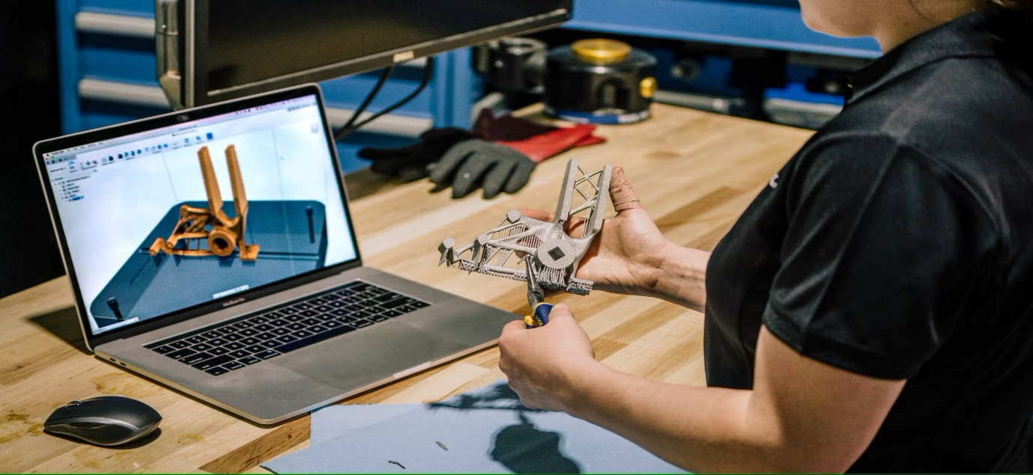

1. **Fusion fundamentals**

The Fusion fundamentals path introduces key Fusion concepts, before showing how to start with modelling. The path also contains video series on design concepts, working with files and projects, using the Fusion web client, and transitioning from other systems:

1. Introduction to Fusion.
2. Start with modelling.
3. Understanding Fusion design concepts.
4. Working with files and projects.
5. Subscription and hub management.
6. SOLIDWORKS transition guide.
7. Mastercam transition guide.
8. **3D modelling**
   * 1. Sketch basics.
     2. Part modelling with Fusion.
     3. Mesh modelling with Fusion.
     4. Introduction to 3D modelling.
     5. Advanced part modelling techniques.
     6. Direct modelling with Fusion.
     7. Sheet metal with Fusion.
     8. Conceptual modelling fundamentals.
     9. Principles of digital prototyping.
9. **Assemblies**
   * 1. Collaboration in distributed designs.
     2. Mechanical assemblies’ fundamentals.
     3. Creating assemblies
10. **Configurations**
    * 1. Configurations.
11. **Manufacturing – Milling, Turning and inspection.**

*Additional machining capabilities are available as a Fusion extension.*

* + 1. Milling basics.
    2. Turning basics.
    3. 3D machining.
    4. The tool library
    5. Toolpath template libraries.
    6. 3+1 and 3+2 milling.
    7. Inspection

1. **Manufacturing – Additive**

Additional additive manufacturing capabilities are available as a Fusion extension.

* + 1. Additive FFF and SLA technologies.
    2. Design for additive manufacturing with Fusion.

1. **Fusion extensions**

These Extensions videos show capabilities that require a Fusion extension. Many extensions are available for a 14-day free trial. Scan the following QR-code for more information:

1. Design Extension.
2. Manufacturing Extension – Machining.
3. Manufacturing Extension – Nesting and fabrication.
4. Manufacturing Extension – Additive.
5. Manage Extension.
6. Simulation Extension – Generative design.
7. Simulation Extension – Simulation.
8. **Generative design**

*The generative design path includes a series of five videos that will guide you through the generative workflow, key features, and concepts. To start with Fusion Generative Design, we Autodesk recommend that you complete the list as follows:*

1. Fusion Generative Design.
2. Fusion basics for Generative Design.
3. Defining a design space.
4. Setting up design requirements.
5. Exploring outcomes.
6. Using Inventor, Desktop Connector, and Fusion for generative design.
7. 2.5-axis milling and 2-axis cutting tips.
8. Introduction to generative design.
9. **Electronics design.**
   * 1. Electronics fundamentals
     2. ECAD

1. **Simulation**
   * 1. Getting started with simulation.
     2. Injection moulding simulation.
     3. Thermal analysis.

1. **Design documentation**
   * 1. Introduction to Fusion drawings.
     2. Setting up views.
     3. Annotating a drawing.
2. **Related learning**
   * 1. Basics of T-splines and the Script workspace.
     2. Electronics design.
     3. Drawing.
     4. Assembly modelling.
     5. Sketching.
     6. Rendering.
     7. CAM laser cutting.
     8. Animation.
     9. CAM lathe.
     10. Surface modelling.

# 

Highlighting the powerful capabilities of Fusion, with an introduction of key features to help you get the most out of the software.

Scan the QR-code to view the official module provided by Autodesk. Ensure you are connected to a secure network connection on a device running an active Wireguard client before logging into my own Autodesk account for my security and privacy.

## Tutorial 1: Introduction to Fusion

An introduction to the benefits of using Fusion, a cloud-based:

* **C**omputer-**A**ided **D**esign (**C.A.D**) tool,
* Manufacture tool,
* Engineering tool,

designed for collaborative product development.

Scan the following QR-code below to watch Tutorial one’s Introduction video. (Internet is required):

## Video transcript

Fusion is a cloud-based:

* Computer Aided Design (CAD) tool,
* Manufacture tool,
* Engineering tool,

for collaborative product development.

Fusion is a combination of both fast, easy and precise:

* Organic modelling,
* Solid modelling,

to help you create manufacturable designs.

When it comes to design, you can choose from integrated methods such as:

* Free form,
* Parametric sheet metal,
* Direct surface,
* Mesh model editing.

If your design is more on the artistic side of things, one can create a form and then manipulate:

* Faces,
* Edges,
* Vertices,

to achieve your desired geometry.

If your design has finer details